Consortium Frequently Asked Questions

Table of Contents
Important Cycle Milestones 2
Applicant Portal 3
Admissions by Liaison 4
Data Dictionary 6
Export File 6
PDF File 7

Cycle Milestones

Milestone | Date
Round 1
Complete Applicant Data Released | October 18, 2021
Incomplete Applicant Data Released | November 5, 2021
Membership Decisions Communicated to Schools | November 10, 2020
Membership Decision Appeals Open | November 11, 2021
Membership Decision Appeals Deadline | November 25, 2021
Final Membership Decisions Communicated to Schools | November 30, 2021
Schools Can Begin to Enter Admission Decisions | November 22, 2021
Schools Can Access Rankings | November 22, 2020
Schools Can Begin to Enter Fellowship Decisions | November 22, 2020
Admission Decision Deadline | December 8, 2021
Fellowship Decision Deadline | December 10, 2020
School Referred Process Opens | February 1, 2021
Round 2
Membership Decisions Communicated to Schools | February 1, 2021
Membership Decision Appeals Open | February 1, 2022
Membership Decision Appeals Deadline | February 14, 2022
Final Membership Decisions Communicated to Schools | February 18, 2022
Schools Can Begin to Enter Admission Decisions | February 14, 2022
Schools Can Access Rankings | February 14, 2022
Deadline to Enter Admission Decisions to View Rankings | March 2, 2022
Fellowship Selection Meeting | March 9, 2022

Applicants & the Applicant Portal

Q: When Does the Application Cycle Open?
A: The application opens on August 15 every year.

Q: How Do I Access the Application Portal?
A: You may visit the Applicant Portal and create a test account. It is recommended that you use Test in your username.

Q: Where Can I Direct Applicants for Application Support?
A: Applicants can visit the Application Help Center or reach the Customer Support Team at consortiumsupport@liaisoncas.com or 617.612.2921.

Q: Will Applicants Be Able to Reapply in the 2021-2022 Cycle or Create a New Account?
A: In the 2021-2022 application cycle and beyond, applicants will have the option to reapply using the same application account they created in the previous cycle. Applicants should not create a new account with a new email address if they intend to reapply.

Q: Is There a Limit on the Number of Colleges Attended Applicants Can Report?
A: No, there is no limit to the number of schools an applicant can report on their application.

In the export file in Admissions by Liaison, we have included a maximum of six school entries, but each school may set a different maximum on their individual export file.

Q: Is There a Limit to the Number of Transcripts an Applicant Can Upload?
A: An applicant can only upload one transcript per school reported in the Colleges Attended section of the application.

Q: Is There a Limit to the Number of Standardized Tests an Applicant Can Report?
A: No, there is currently no limit to the number of tests an applicant can report on their application.

In the export file in Admissions by Liaison, we have included a maximum of one official test, but each school may set a different maximum and filter by self-reported and/or official on their individual export file.

Q: How Do Applicants See Their School Rankings Post-Submission?
A: This information is not available within the application, but they will receive an email within 48 hours of submission of their application which will include their rankings. If an applicant contacts you regarding their rankings, please direct them to The Consortium.

Q: Can an Applicant Change their School Rankings Post-Submission?
A: Once an application is submitted, school rankings cannot be changed. If an applicant contacts you regarding their rankings, please direct them to The Consortium.

Admissions by Liaison Access & Support

Q: How Can I View My Applications in Admissions by Liaison?
A: You can log into the 2022 Admissions by Liaison portal to access complete applications on October 18, 2021 and incomplete applications on November 5, 2021. If you need access the 2021 Admissions by Liaison portal, please click here.

Q: How Do I Request an Account for Other User(s) at My School?
A: Please send a request with the user’s name and email address to Victoria Wayne.

Q: Who Can I Contact for Support?
A: Email Admissionssupport@liaisonedu.com or call 617.221.7838 and a member of our customer support team will assist you.

Admissions by Liaison Applicant IDs

Q: What Do the Different IDs in Admissions by Liaison Mean?
A: There are three IDs in Admissions by Liaison.

- CAS ID: This ID is assigned to an individual application record when an applicant creates an account in the application portal. Example: Adam Ant creates an application in the applicant portal, which is assigned ID 6012991259. This will display in the CAS ID field in Admissions by Liaison.

- CAS Application ID: This ID is assigned to an applicant in Admissions by Liaison and is cycle specific. Example: Adam Ant creates an application in the applicant portal and submit two application designations. He now has an application record in Admissions by Liaison and each of the three designations will be assigned this ID, which is unique to the applicant and CAS, but the same across all of this applicant’s designations. This will display in the CAS Application ID field in Admissions by Liaison.

- Public ID: This ID is assigned to each individual application designation in Admissions by Liaison. Example: Amy Adams creates an application in the applicant portal and submits four application designations. She now has an application record in Admissions by Liaison and each of the four designations will be assigned a unique ID. These four unique IDs will display in the Public ID field in Admissions by Liaison.

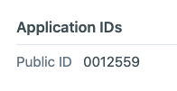

Admissions by Liaison Dashboard

Q: How Do I Edit My Dashboard in Admissions by Liaison?
A: As a school user, you have access to edit your individual dashboard view. Once logged into Admissions by Liaison, click ‘Dashboard’ then ‘Edit Dashboard’. You can rearrange the layout and add various charts and data.

Admissions by Liaison Contacts

Q: How Do I Access My Contacts in Admissions by Liaison?
A: Log into Admissions by Liaison, navigate to the drop-down menu at the top of the screen, and click ‘Contacts’. Your default view should be ‘Students’. If it is not, click on the drop down menu at the top of the screen and navigate to ‘Students’.

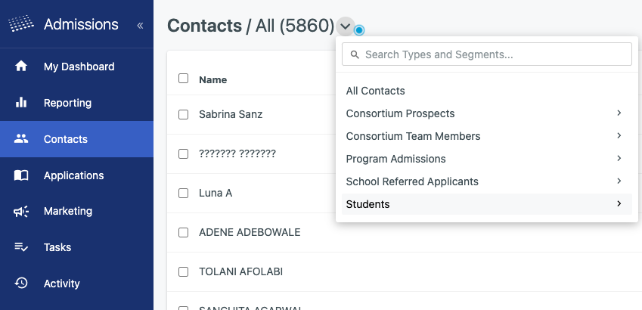

Q: Are Contacts in Admissions by Liaison Specific to My School?
A: Contacts include inquiries, prospective, and all in progress applicants and are not school specific. Visibility will be limited to basic contact information like name and email address and if an applicant has not designated your school, you will not be able to view their applicant data.

Admissions by Liaison Tasks

Q: If I Crate a Task, Do All Admissions Users Have Access to Them?
A: All admissions users at your school will have access to any task that is created.

Admissions by Liaison Inquiries

Q: How Do I Download the Weekly Inquiry Report?
A: Follow the Managing Exports & Export Schedules instructions. The report is updated weekly on Friday at 12:00am ET and will include inquiries submitted in the past seven days.

Admissions by Liaison SSN

Q: How Do I View an Applicant’s Social Security Number?
A: Social security numbers are not visible in an application record and are hidden as a concealed field within Admissions by Liaison.

SSNs can be included in the individual school export file but to view it, a school that requires SSNs must specifically request access to concealed fields. This request can be sent to Victoria Wayne at the Consortium.

Admissions by Liaison Admission Decisions

Q: Am I Required to Report Admissions Decisions in Admission by Liaison?
A: Yes. All admission decisions must be submitted in Admissions by Liaison to access applicant rankings and make fellowship decisions.

Q: How Do I Make Admission Decisions on My Applicants?
A: You can start entering admission decisions on applicants on November 22, 2021. See the Entering Admission Decisions on Applicants instructions.

Q: Will Admission Decisions be Available to Applicants Once I Submit Them?
A: The Consortium does not share any admissions decisions for any applicants. Applicants are notified of membership and fellowship decisions on Monday, December 15, 2021, and March 17, 2022.

Q: Am I Able to Update Admission Decisions on an Applicant?
A: Yes. You can log into Admissions by Liaison at any time and change the decision on an application or a group of applicants following the instructions on

Admissions by Liaison Applicant Rankings

Q: How Do I View Applicant Rankings?
A: Applicant rankings are accessible within 24 hours of submitting entering an Accepted (AC) admission decision on them. See the Viewing Applicant Rankings instructions.

Admissions by Liaison Fellowship Decisions

Q: Am I Required to Report Fellowship Decisions in Admissions by Liaison?
A: Yes. All fellowship decisions must be submitted in Admissions by Liaison.

Q: How Do I Update Fellowship Decisions on My Applicants?
A: Fellowship decisions cannot be made in batch and must be made individual via each application record. See the Entering Fellowship Decisions instructions.

Admissions by Liaison Official Test Scores

Q: How Do I Know Test Scores are Official in Admissions by Liaison?
A: Liaison has official test score integrations with both ETS (GRE) and GMAC (GMAT). Any test score received in Admissions by Liaison and labeled as ‘official’ is an official score sent to our system directly from the test service provider.

Liaison only receives raw score files and does not receive individual applicant PDF official scores, so you will not see individual score PDFs for any applicant in Admissions by Liaison. See the screen shots below for official score view in Admissions by Liaison:

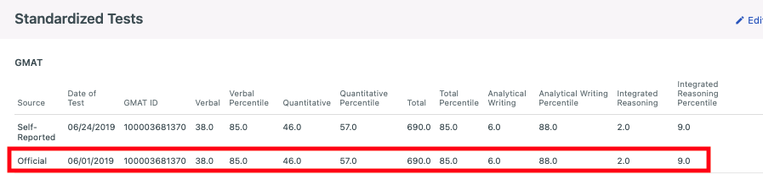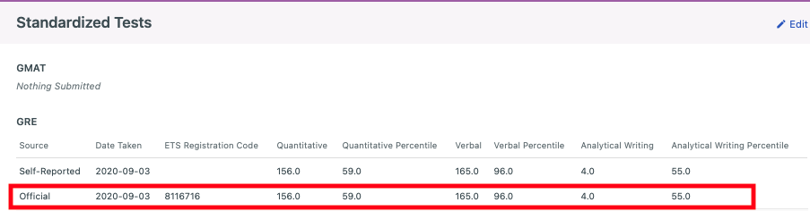

Data Dictionary

Q: Where Can I Access the Data Dictionary?
A: The most up to date data dictionary can be downloaded here.

Q: Why are My Supplemental Question Not Appearing in the Data Dictionary?
A: The data dictionary is a global CAS document and will not contain school-specific supplemental fields. School-specific supplemental fields are included in your individual export file.

Q: What Are All Possible Values & Formats for All Fields?
A: This information will be found in the data dictionary.

Q: Where Can I Find a List of College/CEEB Codes?
A: The Master School Code list is found here.

Admissions by Liaison Data Export File

Q: How Can I Update My Export File?
A: All export update requests must go through Victoria Wayne at The Consortium as the owner of all exports. School users may not edit export files and may only edit or add export schedules.

Q: How Can I Manually Download My Export Files?
A: Follow the Managing Exports & Export Schedules instructions.

Q: How Will Dates Appear in the Export File?
A: If the date field is a Liaison standard field, it will read as 2019-12-31T00:00:00 by default. If the date field is input as a text field, it will read exactly as the applicant enters the date.

Each school may set a different date format option on their individual export file from the options below:

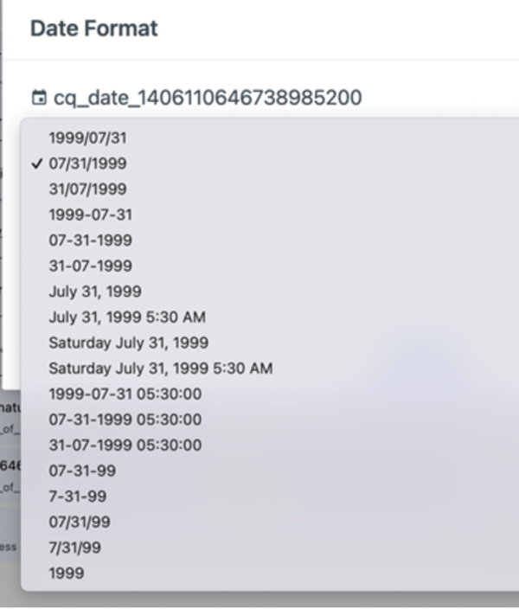

Q: Do I Need to Whitelist IP Addresses if I am Exporting to a Destination?
A: If you will be exporting to a destination, you must whitelist the following IP addresses for a successful file delivery to occur:

- 34.236.56.236
- 52.201.147.233
- 54.156.209.141

Q: Does the Export File Have a Delimiter Option?
A: There are three export file configuration options: Comma Delimited, Tab Delimited, and Fixed Width.

Admissions by Liaison PDF File

Q: How Long are PDFs Available in Admissions by Liaison?
A: There is no expiration date to access PDFs in Admission by Liaison.

Q: Can the PDF be Customized?
A: The PDF is a global system document and cannot be customized by CAS or by school. As enhancements are made to the global PDF, those updates can be rolled out to The Consortium’s PDF.

Q: Will the PDF Zip File be Password Protected?
A: It is not password protected.

Q: Will the PDF Zip File Contain Recommenders and Application PDFs Together or in Separate Files?
A: There is a single PDF per applicant with all data and documents included in the single file.

Q: Help! The Number of PDF Files Available in My Export Does Not Match the Number of Applicants on My Applications Grid.
A: This is expected behavior. The PDF files pull from the Complete with References segment, which requires applicants to have all three references received before being delivered in the PDF file. To view the correct number on your Applications Grid, filter by:

- Category: All
- Segment: Complete with References – School Name

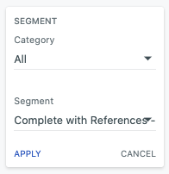

The number shown on the Applications Grid will match the numbers you are seeing in your PDF export file.

Q: Can I Receive Application Documents Separately?
A: There is an option to receive a full application PDF with all documents included in a singular file as mentioned above and also an option to receive the full application PDF and the documents individually (such as transcript, resumes, and letters of recommendation). This must be configured. If interested, please reach out to Victoria Wayne.

Q: What is the Standard Naming Convention for the PDF Zip File?
A: School Name Daily PDF Export Template – {{date}}

Q: What is the Standard Naming Convention for Individual Applicant PDFs?
A: {{Applicant.fullName}} – {{application.publicId}} – {{date}}

Q: How Do I Manually Download My PDF Export Files?
A: Follow the Managing Exports & Export Schedules instructions.

