**University of Hawaii at West Oahu**

**Application Configuration**

**Index**

1. Application Forms
2. Program
3. Student Portal

**Steps**

**Application Forms**

1. List of ALL Forms for the Spring 2024 Program

1. Breakdown of each Application Form

*Citizenship Form*

*Courses, Grades, Scores*

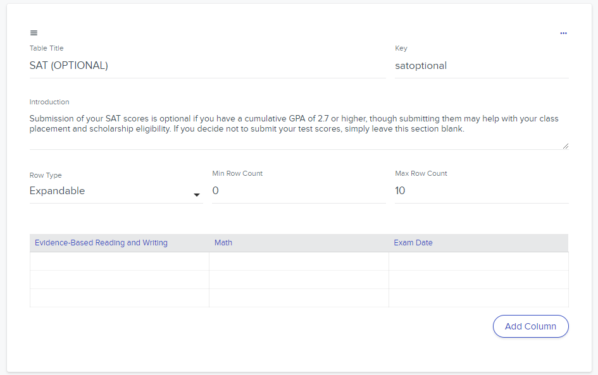

*English Proficiency*

*Fee Waiver*

*Final Steps*

*General Data Protection Regulation*

*High School*

*High School Counselor*

*Other Background*

*Personal Information*

*Previous College Coursework*

*Race & Ethnicity*

*Relocation Confirmation*

*Residency*

*\*\*Javascript available here (link the JS document)\*\**

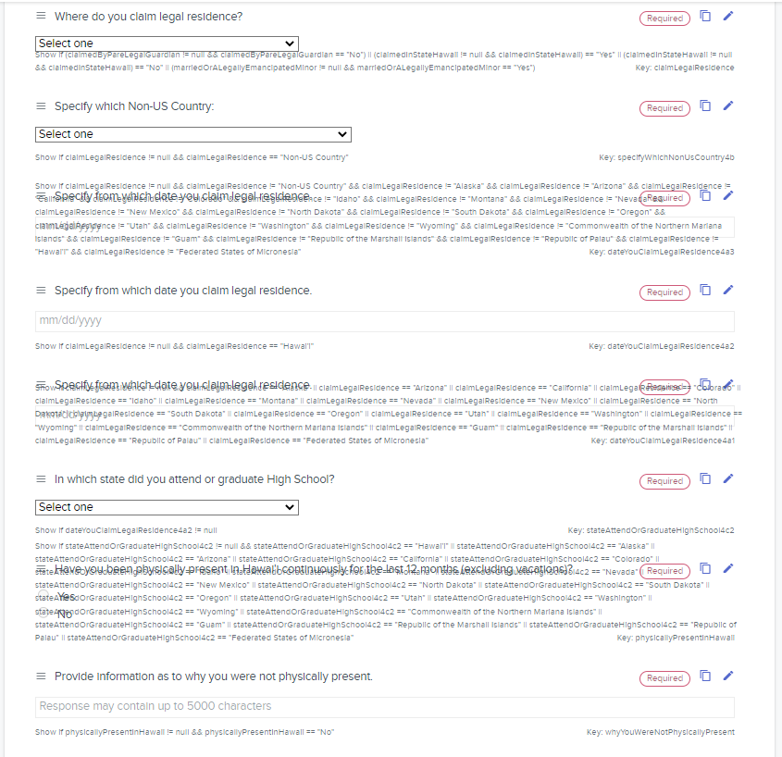

*Your Address*

*Your College Plans*

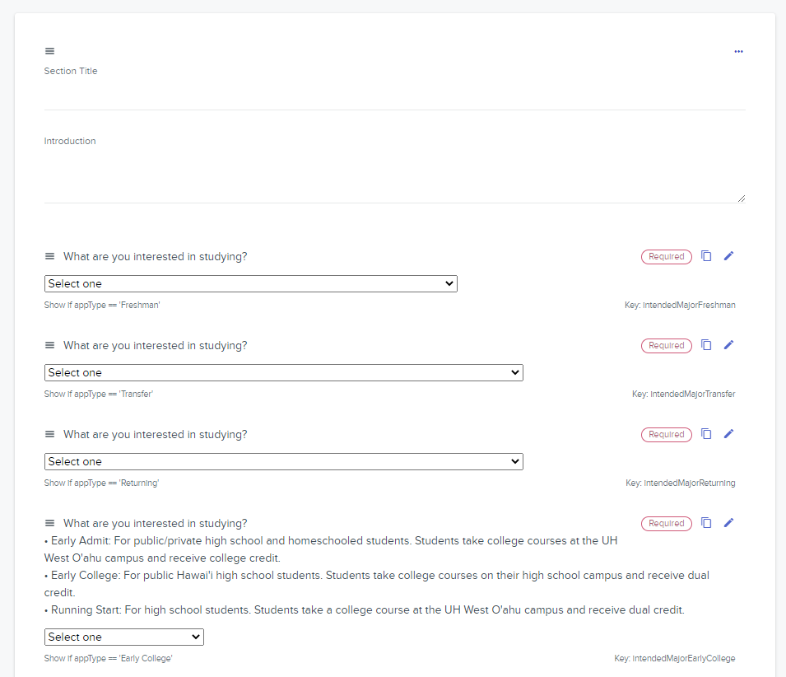

*Your Family*

**Program**

1. List of Program(s)

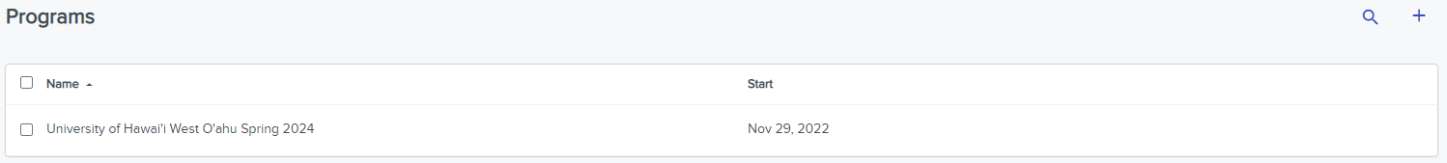

1. Program Details

1. Application Stage: Undergraduate Application Details

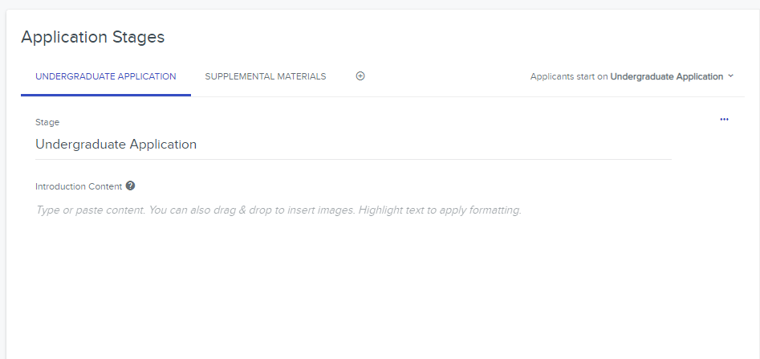

1. Setting and Program Properties

1. Content Section Details

*ABOUT YOU*

*ACHIEVEMENTS*

*FINAL STEPS*

*NEXT STEP: Your Application Fee Waiver Request will be reviewed. Please do not submit your application yet.*

1. Submit Step

1. Conditional Visibility in Checklist and Checklist Items

*OFFICIAL TRANSCRIPTS - Checklist*

*High School Counselor Checklist Item*

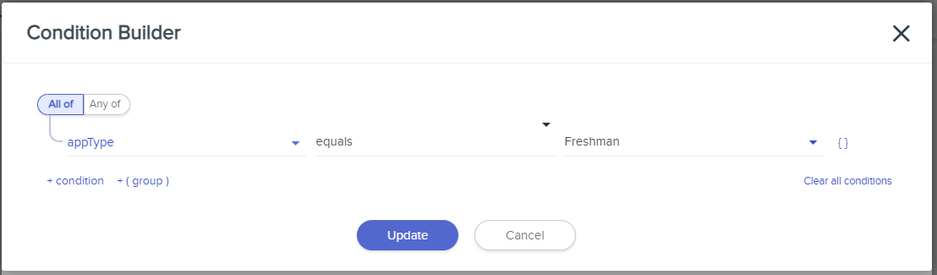

*Courses, Grades & Scores Checklist Item*

*English Proficiency Checklist Item*

*Your Family Checklist Item*

*NEXT STEP: Your Application Fee Waiver Request will be reviewed. Please do not submit your application yet. Checklist Item*

**Student Portal Setup**

1. URL Link: [https://student-hawaii-undergraduate-westoahu-prelaunch.admissionsbyliaison.com](https://student-hawaii-undergraduate-westoahu-prelaunch.admissionsbyliaison.com/)

1. Student Portal Settings

